**Mechi Multiple Campus**

(Tribhuvan University)

Bhadrapur, Jhapa



**Lab Report of**

**Data Structures and Algorithm (CACS-201)**

**Implementation of Sorting Algorithm**

Faculty of Humanities & Social Sciences

Tribhuvan University

Kritipur, Nepal

**Submitted By**

**Name:** Santosh Bhandari

**Roll No:** 58

**Submitted To**

Mechi Multiple Campus

Department of Bachelor in Computer Application

Bhadrapur, Jhapa, Nepal

**Program Code**

#include<stdio.h>

void main(){

int n,num[100],i,j,temp;

printf("How Many Number You Want to Insert: ");

scanf("%d",&n);

for(i=0;i<n;i++){

printf("Enter a Number: ");

scanf("%d",&num[i]);

}

for(i=0;i<n;i++){

for(j=0;j<n;j++){

if(num[j]>num[j+1]){

temp=num[j];

num[j]=num[j+1];

num[j+1]=temp;

}

}

}

printf("Sorted Data: \n");

for(i=0;i<n;i++){

printf("%d\t",num[i]);

}

}

**Output of the Program**

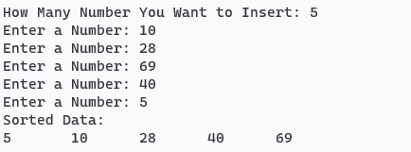

**Program Code**

#include<stdio.h>

void main(){

int n,num[100],i,j,temp,min,loc;

printf("How Many Data You Will Insert: ");

scanf("%d",&n);

for(i=0;i<n;i++){

printf("Enter a Number: ");

scanf("%d",&num[i]);

}

for(i=0;i<n;i++){

min=num[i];

loc=i;

for(j=i+1;j<n;j++){

if(num[j]<min){

min=num[j];

loc=j;

}

}

temp=num[i];

num[i]=num[loc];

num[loc]=temp;

}

printf("Sorted Data: \n");

for(i=0;i<n;i++){

printf("%d\t",num[i]);

}

}

**Output of the Program**

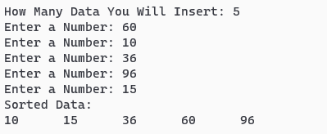

**Program Code**

#include<stdio.h>

void main(){

int num[100],n,ptr,i,j,temp;

printf("How Many Data You Will Insert: ");

scanf("%d",&n);

for(i=0;i<n;i++){

printf("Enter a Number: ");

scanf("%d",&num[i]);

}

for(i=0;i<n;i++){

temp=num[i];

ptr=i-1;

while(temp<num[ptr]&&ptr>=0){

num[ptr+1]=num[ptr];

ptr--;

}

num[ptr+1]=temp;

}

printf("Sorted Data: \n");

for(i=0;i<n;i++){

printf("%d\t",num[i]);

}

}

**Output of the Program**

